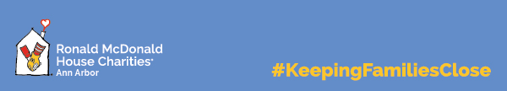

TOP WISHLIST ITEMS

Your donations will help create a “home away from home” for families whose children are receiving treatment at area hospitals. Thank you for your generosity and support of our families!

Special notes: For infection control purposes, we are unable to accept used or previously owned items. All kitchen and linen donations must be new. Please check expiration dates on food items. Snacks and foods such as crackers and cereals need to be individually packaged.

Items:
- Pop tarts
- Fleece blankets
- Umbrellas
- Individually wrapped cutlery; not knife/fork/spoon combo
- Restaurant gift cards
- Grocery delivery gift cards
- Bed items:
  - Pillows
  - Pillow protectors
  - White Twin sheet sets and Twin blankets
  - Queen-sized sage green sheet sets
- Post-it notes
- Scotch tape
- Small pocket-sized/purse-sized notebooks
- Water bottles (Nestle, Dasani, etc.)

Donations can be dropped off at the House, located at 1600 Washington Hts. in Ann Arbor, between 9 a.m. and 9 p.m., weekdays and weekends. Place items in the donation bin located in the parking lot and follow the directions posted.

THANK YOU!

